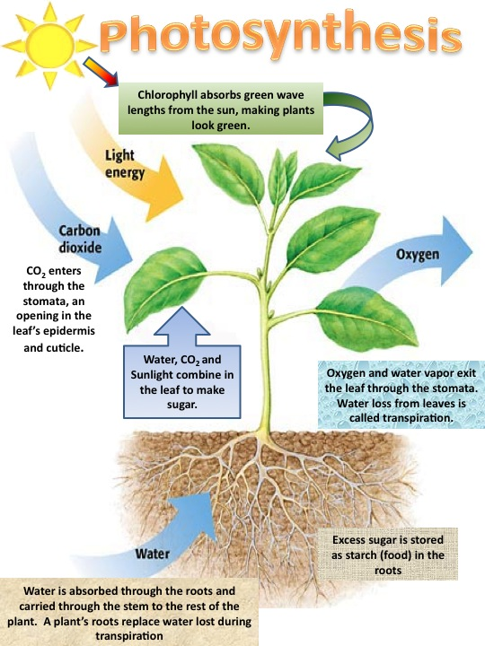

Directions: Complete the photosynthesis diagram above by adding the missing word(s) to each box

Use the science text book and hand-outs in IAN to assist you with completing the information about photosynthesis below.

When _________________ strikes a plant’s ________________________ it sets in motion the process known
as ______________________________________________. Besides ____________________ energy plants
also need the raw materials of _________________________________ and _________________________ to
power photosynthesis. Plants use energy absorbed by ___________________________________, a chemical
found in the __________________________ cell of a plant’s leaves. When the raw materials of water and
carbon dioxide combine with light a ___________________________ reaction occurs. This produces a
_________________ or carbohydrate that serves as food for the plant and produces
_____________________. These results of photosynthesis are known as products.
The process of photosynthesis can be described in an equation:

C02 + H20 C6H1206 + 02
Identify the components of the photosynthesis process below
C02 = ______________________

H20 = _______________________

= ____________________________

C6h1206 = ________________________

02 = ____________________________

Write out the photosynthesis process in word form below. Lightly color the raw materials blue and the products green.

